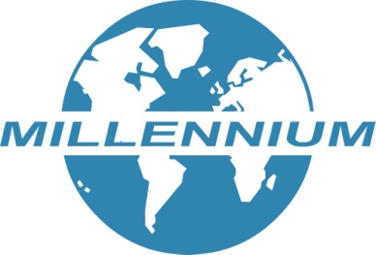

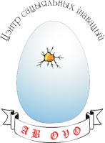
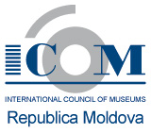
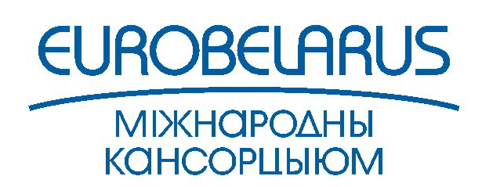
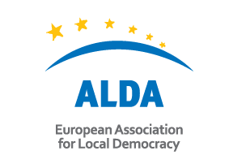
GUIDELINES FOR THE CALL FOR PROJECT PROPOSALS
“CHOICE-BELARUS: HERITAGE AND MODERNITY”

Association of Local Democracy Agencies ALDA (France) together with International Consortium “EuroBelarus” (Lithuania), Centre for Cultural Management (Lviv, Ukraine), ICOM National Committee (Chisinau, Moldova), Millennium Foundation for Education and Research (Erevan, Armenia), and Public Association “Centre for Social Innovations” (Belarus) announce the call for project proposals “CHOICE-Belarus: Heritage and modernity”.

MAJOR GOALS AND PRIORITIES OF THE CALL FOR PROJECT PROPOSALS
This call for project proposals is organized within the frames of the international project “CHOICE - Cultural Heritage: Opportunity for Improving Civic Engagement”.
The major goals of the CHOICE project are:
- developing civil society organizations (SCO), working in the field of local development, protection and rehabilitation of culture heritage,
- spreading the practice of SCO's national, local, as well as regional (international) participation in decision-making in the cultural field in their countries,
- expanding the use of innovative approaches and spreading civil society initiatives on including cultural heritage into the modern cultural life of the society.
Put into practice, these goals will be reached through:
- Support to cultural non-governmental organizations and professional associations in organizing innovative projects on preservation and actual interpretation of national cultural heritage;
- Increasing professional capacity, organizational potential, and enforcing the role of civil society organizations in shaping local and national cultural environment and cultural policies both in their country as well as in the Eastern Partnership region in general.
SELECTION CRITERIA
We invite to apply for the project:
- non-governmental organizations of local and/or national level, working in the field of local development, protection and rehabilitation of culture heritage from the countries-participants of the project (Armenia, Belarus, Moldova, and Ukraine);
- organizations, groups, associations of professionals and intellectuals, and cultural figures interested in the possibilities of preserving the cultural landscape and its diversity, as well as in ensuring a stable use of the cultural heritage resources for the development of towns and communities.
Submission of partnership (joint) applications from organizations from countries-participants of the project is welcomed.
Preference will be given to the SCOs working in remote rural areas outside capitals or in the regions that are facing problems with the objects of cultural heritage.
Organizations can apply for support of two types of projects:
- creative concepts: projects that are promoting environment where cultural heritage is preserved, reinterpreted, and used; that are emphasizing the importance of such environment for moulding Belarusans' contemporary national identity, as well as projects that are stimulating dialog about that between different interested parties and development of corresponding partnerships;
- organization development plans: projects that include work for improving working processes and procedures, fundraising mechanisms, financial management in organizers-applicants; that provide for measures to prevent corruption and measures to develop transparency of CSO's work. In particular, such projects can include organizational and financial audit expenses.
The following criteria will be applied to the applicants:
In order to have the right to ask for support, applicants should be:
- non-governmental organizations;
- civil society organizations and initiatives;
- organizations from Armenia, Belarus, Moldova or Ukraine (the location where the main office, main activities or registration is);
- directly responsible for preparing and managing the project, not acting as an intermediary.
REQUIREMENTS FOR DEVELOPING A PROJECT PROPOSAL
Projects can be submitted both by one organization and in partnership with the colleagues from either the same country or from some other country- or countries-participants of the project (Belarus, Armenia, Moldova, and Ukraine).
Duration of the projects:
Projects should last no less than 6 months and no longer than 14 months.
Planned terms of realization: starting from March 1, 2016 and not later than May 1, 2017 (the deadline for reports).
Financial frames of the provided support:
- The sum of grant for a thematic project cannot exceed 60 000 euro for a project; minimal amount is 5000 euro. At least 10 per cent from the general cost of the project should be paid in by the organizations-applicants.
- The sum of grant for a project on organizational development makes from 1000 to 3000 euro for one organization; the organization's own financial input of 10 per cent from the general cost of the project is also needed.
Both types of grants for organization will be considered and offered in the same time period.
Project location:
Project activities should take place in the countries-participants of the project (Armenia, Belarus, Moldova, and Ukraine) in the regions where cultural heritage objects require biggest attention and protection, outside capital cities. Projects can be both national (within the frames of one country) as well as touch upon regional problems (within the frames of the Eastern Partnership region).

THEMATIC PRIORITIES
The range of subject areas and formats can comprise:
- mapping of cultural objects, cultural heritage tours;
- creation of mobile applications for promoting concrete cultural heritage objects;
- promotion of modern methods and technology for rehabilitation of cultural landscapes;
- mobilization of local communities for participating in local planning and having influence on the development of the cultural policy and its monitoring;
- as well as other innovative projects, fresh creative ideas, and ambitious initiatives based on authors’ aspiration to improvement and the ability to influence local and national cultural processes.
Projects can include the following activities, on condition that they fit in the frames of program goals and priorities: exchange of best practices, educational activities (training courses, seminars, and workshops), building partnerships and networks, information campaigns, educational events, conferences; summer camps and other volunteer events; publications, audio-visual productions, exhibitions, research, etc. (the list is open). Capital and construction expenditures are not supported.
Important:
Organizers consider realization of a thematic project as a means of NGOs’ and civic initiatives’ development, their organizational, innovative potential, in- and inter-state relations.
Organizations with the selected projects will also have to confirm their ability to work in accordance with the democratic norms and procedures inside organizations as well as demonstrate presence of organization’s system of internal control and ability to conduct financial reporting at the level required by the grant makers.
Projects cannot be supported if containing:
- exclusively or mostly expenses for participation in conferences, seminars, congresses as well as individual scholarships for participation in research or studies;
- projects in formal education;
- one-time conferences (conferences can be supported if they are a part of a broader range of activities that exclude preparation for the conference and publication by its results);
- projects exclusively consisting of capital expenditures, construction, purchase of equipment and vehicles (despite the fact that the purchase of the necessary equipment can take place when justified);
- projects of discrimination nature towards certain groups of people according to their gender, sexual orientation, religious or ethnic affiliation;
- projects aimed at supporting political parties including proselytism.
QUANTITATIVE AND QUALITATIVE SELECTION CRITERIA THAT WILL BE TAKEN INTO ACCOUNT BY THE SELECTION COMMITTEE
Quantitative (for thematic projects):
- expected number of target group representatives involved in the project (adequate number relative to the goals of the project); the number of representatives of various stakeholders, including local authorities or business involved in the project activities.
Qualitative:
- the project’s originality and novelty; its ability to involve those civil society groups that haven’t been previously involved in such kind of projects; potential sustainability of the project; the project’s relevance for the needs of the community in which it is being implemented; the potential of involving citizens in preservation and promotion of cultural heritage; the potential of developing relations with other stakeholders –local authorities, business, cultural institutions, and other actors in the cultural sphere (for thematic projects);
- improvement of quality of the organization’s working processes; increasing the transparency of the organization’s work; better financial management (for organizational development projects).
APPLICATION PROCEDURE AND SELECTION OF APPLICATIONS
Project applications will be selected by the international jury consisting of experts from countries-participants of the project (one from each country).
Project applications will be selected in 2 stages.
During the first stage (before October 31, 2015) the organizations and initiatives willing to take part in the project have to prepare and send to the electronic address eurobelkultura@gmail.com the following documents:
- creative concept of the cultural project based on the interpretation and actualization of material and non-material cultural heritage of Belarus;
- preliminary plan of the applicant’s organizational development. Future assessment of the organization’s potential will be made based on this plan; selected organizations will be able to elaborate and implement the plan of their organizational development.
During the second stage of selection (before January 20, 2016) the organizations-participants selected during the first stage, with the help of consultants and trainers, will be able to develop and submit project proposals with a detailed budget, as well as finalize the submitted plans on their organizational development. Grants will be provided both for the implementation of creative concepts as well as for implementation of plans of organizational development.
The selected participants will also be able to attend professional seminars and mini-trainings at field-specific organizations from Belarus, Ukraine, Moldova, and Armenia, as well as develop joint projects with partners from these countries. Project partners will provide help in finding partners for the applicants by their request.
It is expected that about 35 projects from 4 countries (including partnership projects) will get support.
Application form is attached. E-application form as well as these guidelines can be downloaded from www.eurobelarus.info.
Applications that are not filled in in accordance with the given form, with missing sections, in case of absence or blank applications, as well as those sent after the deadline won’t be taken to consideration.
The language for filling in the application in Belarus is Belarusian, Russian or English. Applications-concepts of the project should be sent in e-form to eurobelkultura@gmail.com, deadline for submitting concepts is October 31, 2015.
Preliminary deadline for notifying about the results of the selection of concepts and enrolment in the project is November 15, 2015. Preliminary deadline for notifying about allocation of grants is February 15, 2016.

