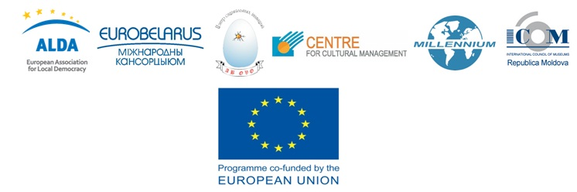
CHOICE – CULTURAL HERITAGE:
OPPORTUNITY FOR IMPROVING CIVIC ENGAGEMENT

PROJECT CONCEPT
Application form

I. Short information about the project
Applicant organization:
The name of the project:
Planned venue for realization of the project:
Duration
(maximum of 14 months):
Starting date:
Ending date:
General cost of the project, EURO:
The sum asked from the CHOICE programme, EURO:
Short description of the project idea (max. 2000 signs):

II. Information about the applicant:
Legal representative (head of the organization):
Contact person:
Name of the organization:
Address:
Email:
Phone, fax:
Web-site (if exists):
Short description of the applicant organization (and partners if it is a partnership project) (country, mission and goals, main field of activity, experience in project implementation):
Main applicant:
Partner 1:
Partner 2:
And so on

III. Project description:
Major problems that your project is going to solve:
Goals of the project:
Expected results:
Target groups
(including the number of people that will be involved):
Planned activities (describe the reason, aim, and method of realization for each activity):
Explain how this project will help to strengthen the role and potential of your organizations for working with cultural heritage issues:
Describe other expected effects from your project (for example, enlarging contacts within the frames of the Eastern Partnership initiative, bigger enrolment and strengthening of civil society role, possible ecologic effects, efficient management, local development, and other):
Please, mark whether your organization is ready to go through a procedure of organizational evaluation? Is your organization ready to provide a report about organizational evaluation (if such took place no later than a year before) to the organizers?
Signature of the representative of the organization, stamp (if exists):
Date and location:
Deadline for application of the concept: | October 31, 2015
 | This project is co-funded by the European Union
ANNOTATION
1. Application shouldn’t exceed 6 pages of text (without appendix)
2. The application should be printed with the use of this form in Belarusian, Russian or English. Hand-written applications and applications filled in with the use of other forms are not accepted!

APPENDIX

BUDGET:

Item in the budget | Unit of measure | Number of units | Price of one unit | General sum in local currency | General sum in EURO
Project in total
Required sum

